**Submitted to:**

Mr. Jordan Puhawan

**Developed by:**

Christian Mark A. Bituin

Rheidelyn Fule

Dionard Jetomo

Zea Luansing

Abstract

A Content Management System for Schools with basic page configurations and design.

School website content management system

FINAL PROJECT IN WEBDEV403

1. **PROJECT CONFIGURATION**

Server

Public DNS: http://ec2-34-229-156-224.compute-1.amazonaws.com/

Provider: AWS EC2

Front-end

Framework: MaterializeCSS

Back-end

Language: Python

Framework: Django 2

Repository: https://github.com/starshaft/dlsp_cms

1. **FEATURES**

School website content management system provides basic functionalities for creating a school website with default pages such as admission, programs, about the school and contact information. The system supports a back-end program that allows users to update the said default pages.

1. **MANUAL**
2. Accessing the admin page
   1. Go to <http://ec2-34-229-156-224.compute-1.amazonaws.com/admin>
   2. Login via default user credentials

Username: admin

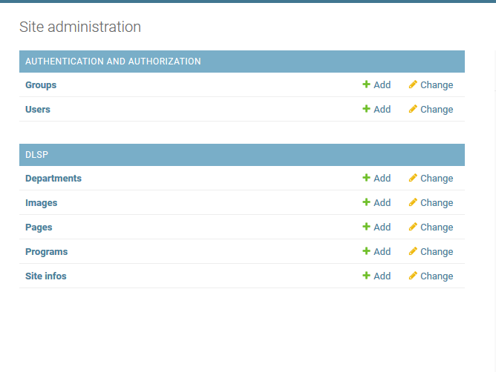Password: admin

1. Updating the site information

On the admin dashboard, go to Site Info

1. Updating page information

On the admin dashboard, go to Pages

1. Updating department and programs
   1. On the admin dashboard, add Departments via Departments Panel
   2. Programs is linked to Departments Panel upon insertion
2. Updating images

On the admin dashboard go to Images Panel and upload file